Jamie Lewis

CST-350

11/24/23

Instructor Donna Jackson

Activity 1: Agile and .NET Foundation

Part 2-B: Create Documents for a Sprint

Page Wireframes

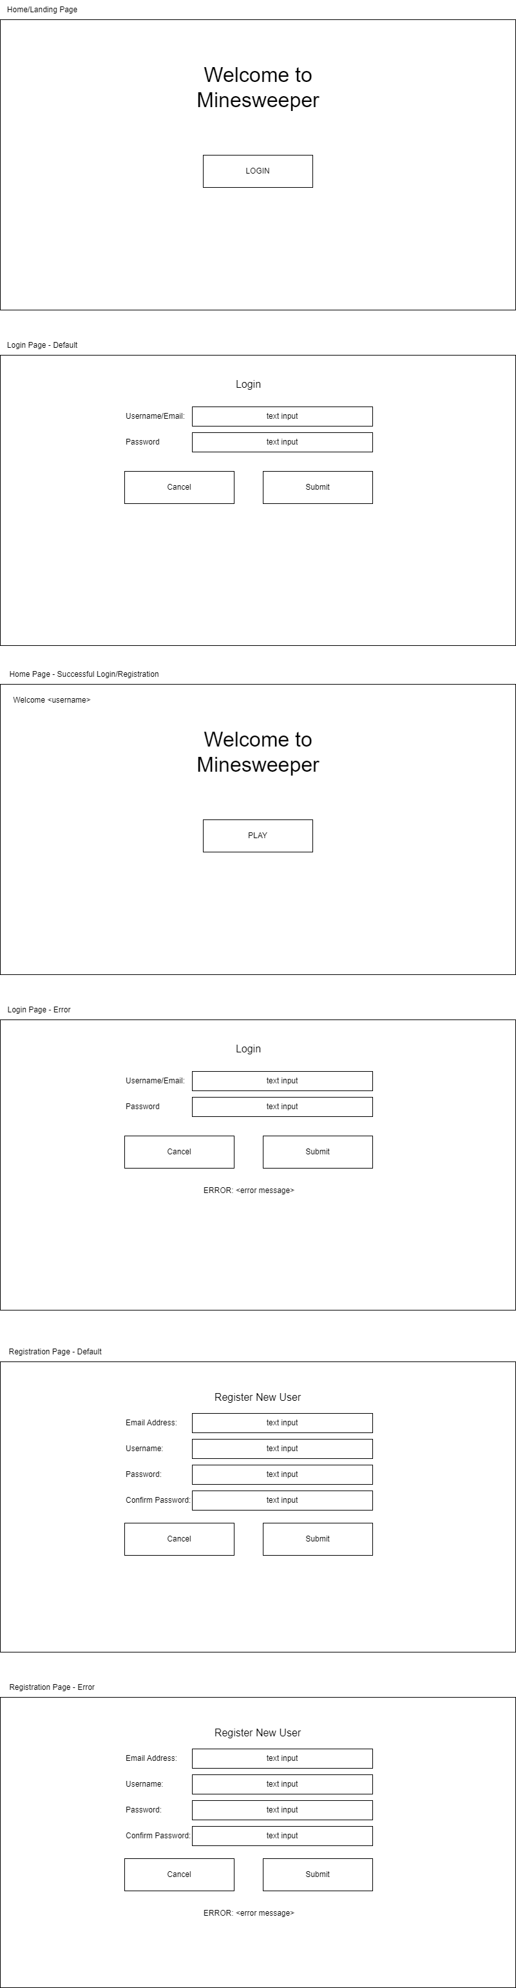

Site Map

Class UML

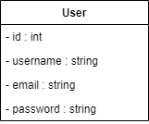

Database Table

